|  |  |  |  |  |  |
| --- | --- | --- | --- | --- | --- |
| Date | 28-Nov-22 | | | Tester Name | Mayuri Patel |
| Environment | Penfax - Test | | | Login used |  |
| Operating System | Windows | Version: | Update: | | |
| Software Used | Edge | Version: | Update: | | |
| Not Applicable | Version: | Update: | | |
| Release version | 22.4.1 | | | | |
| Title | Death | | | | |
| Test Type | Regression | | | | |
| Test Scenario | Change a member's status to deferred survivor | | | | |
|  |  | | | | |
| Expected Results | On entering the Death Date, member status should be updated as ‘Deferred Survivor’ with the effective date of change. | | | | |
| Pass/Fail | Pass | | | JIRA# | N/A |

Describe your steps with screenshots:

1. In PENFAX5 do a search for the PEPP member. Click on the stakeholder ID.

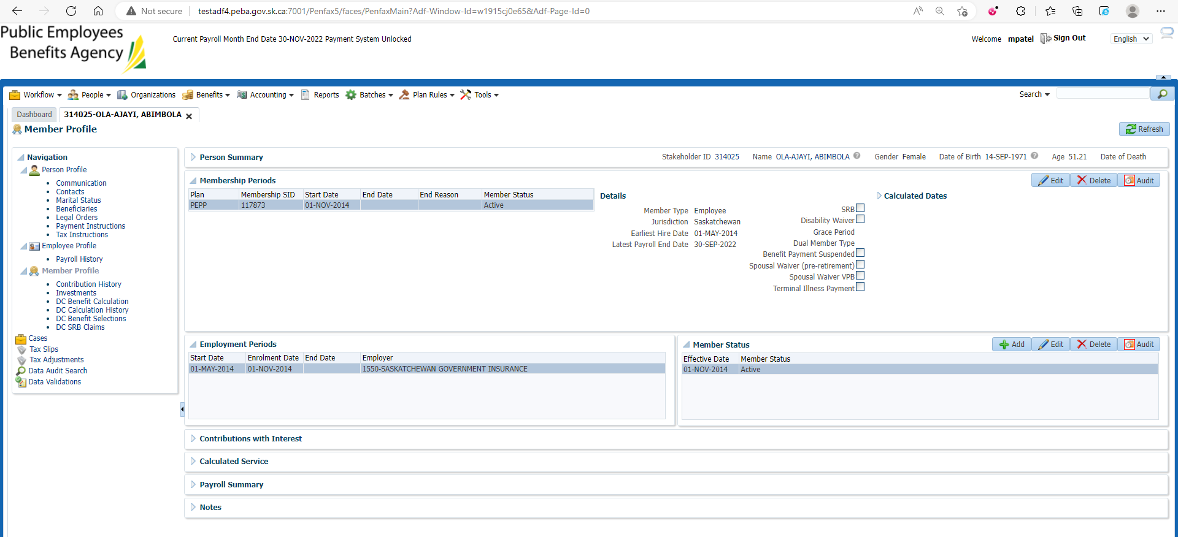

1. Click on the person Profile and then Edit.

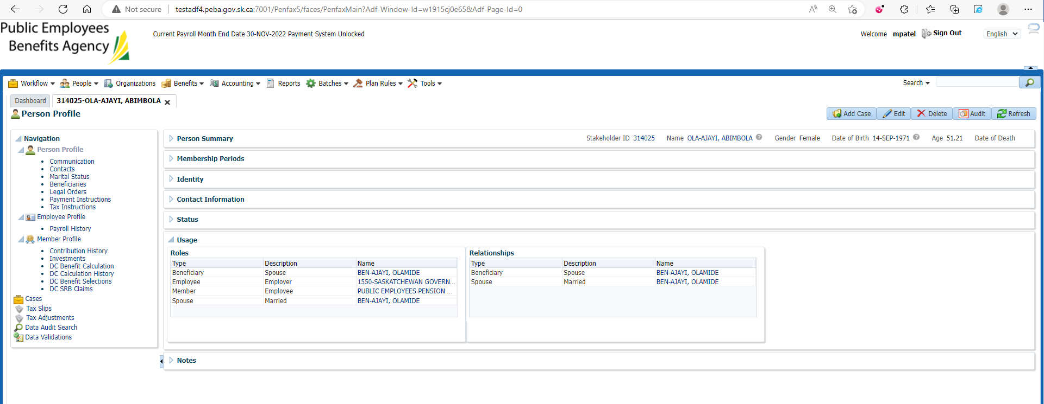

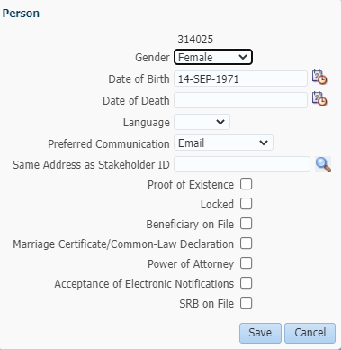

1. Input a Date of Death and Save.

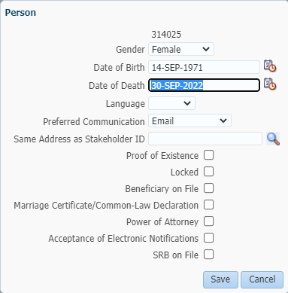

1. Date of Death is displayed under Person Summary tab now.

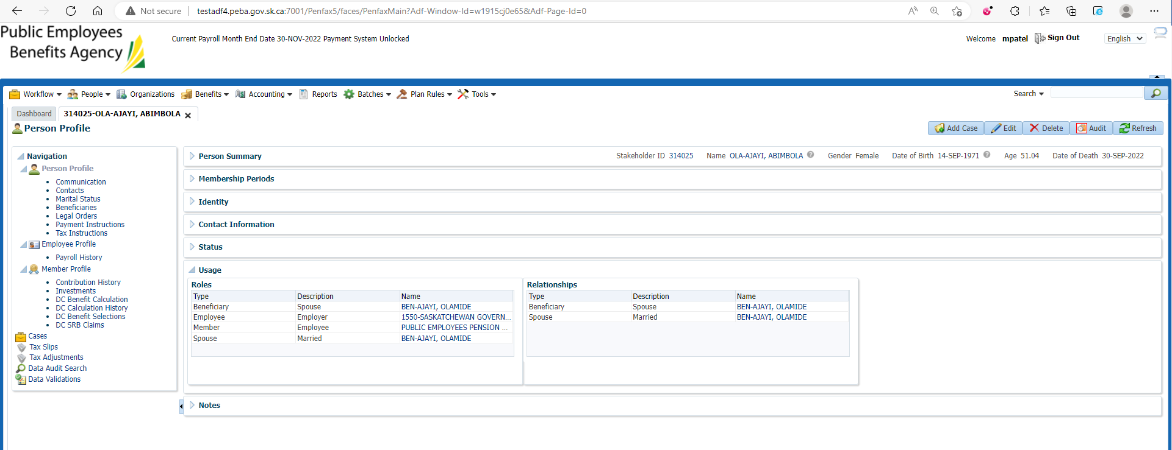

1. Go to Member Profile. Member status should now show as Deferred Survivor.

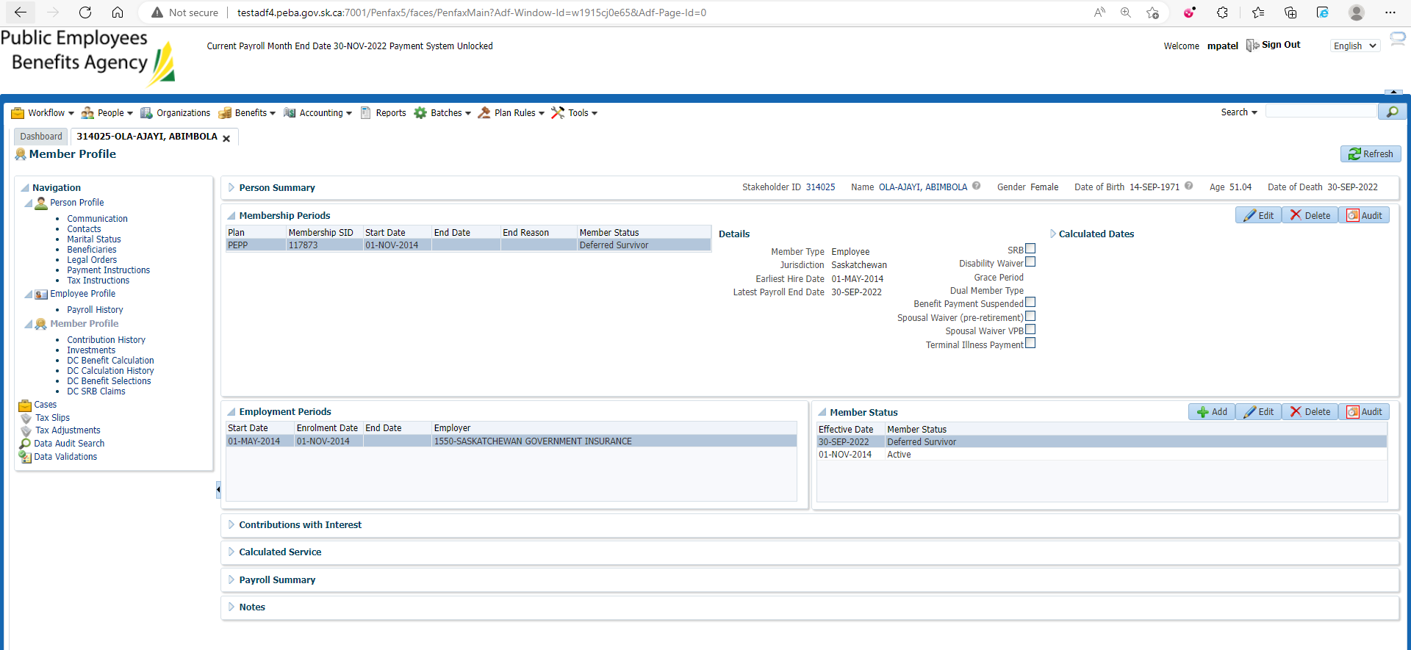

1. Under Member Status box on the bottom effective date with the status change should be displayed.

